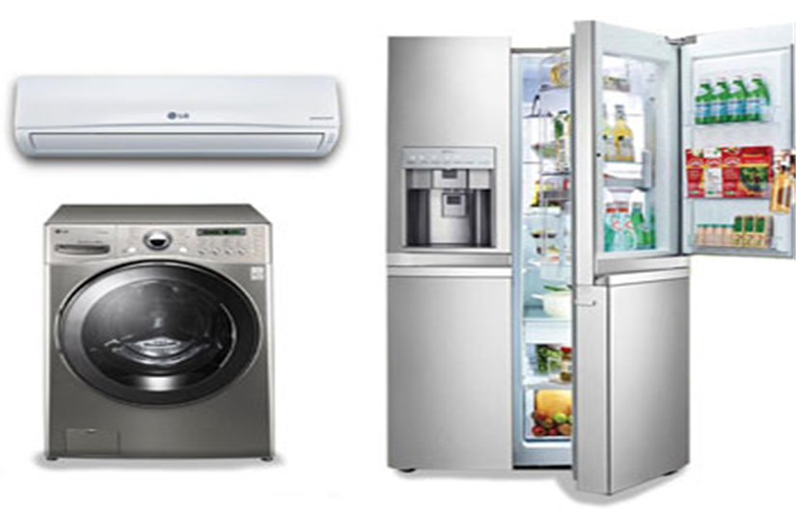

**Extended Warranty White Goods Claims Module**

**Enhancement**

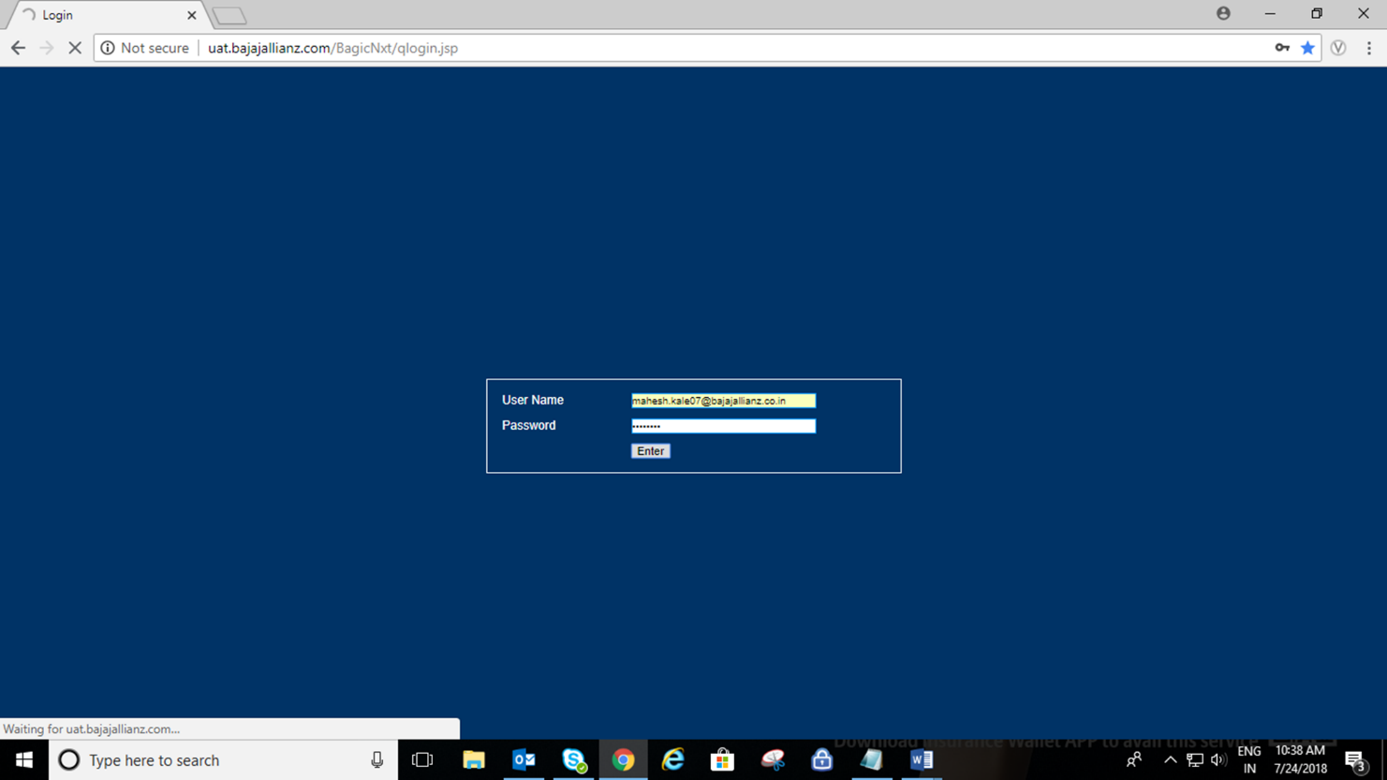

**Logged in with correct user ID & Password.**

**Browser: Google Chrome**

**Login Link:** [**https://general.bajajallianz.com/BagicNxt/qlogin.jsp**](https://general.bajajallianz.com/BagicNxt/qlogin.jsp)

**Policy Search**

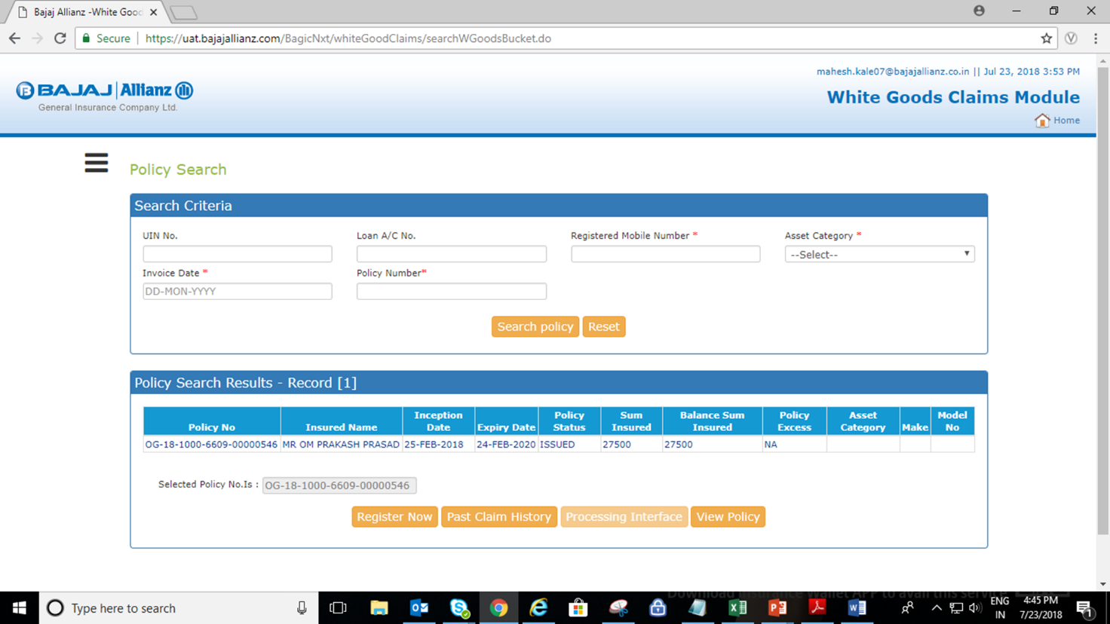

* **Policy Should Search with the below details -**

1. **UIN no –**
2. **Registered Mobile Number.**
3. **Asset Category + Invoice Date + Policy Number**
4. **Policy No.**

* **Button Functionality –**

1. **Register now –To Register new Claim on Policy.**
2. **Past Claim History – To view the Previous Claim Details on the same Policy.**
3. **Processing Interface – To Redirect on the Processing Interface Page.**
4. **View Policy- To download/View the Policy PDF.**

**Enhancement in Past claim history.**

**On Click of “Past Claim History” button system will be reflected previous all registered claim details on single screen.**

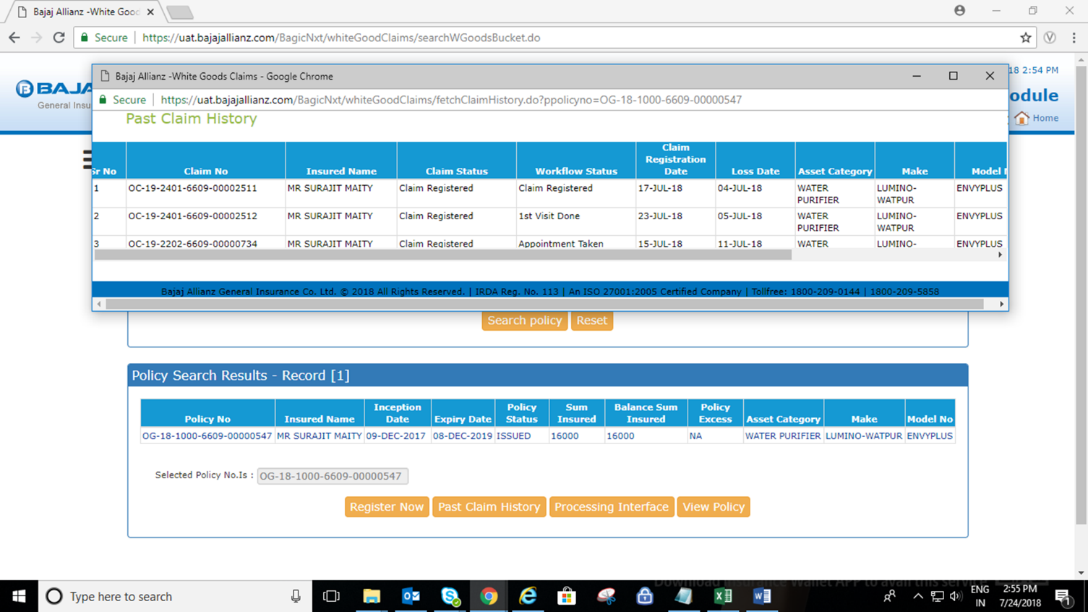

**In Past Claim history below details will be reflected –**

* **Claim No.**
* **Insured Name**
* **Claim Status**
* **Workflow Status**
* **Claim Registration Date**
* **Loss Date**
* **Asset Category**
* **Make**
* **Model No**
* **Balance Sum Insured**
* **Loss Description**
* **Paid Amount**

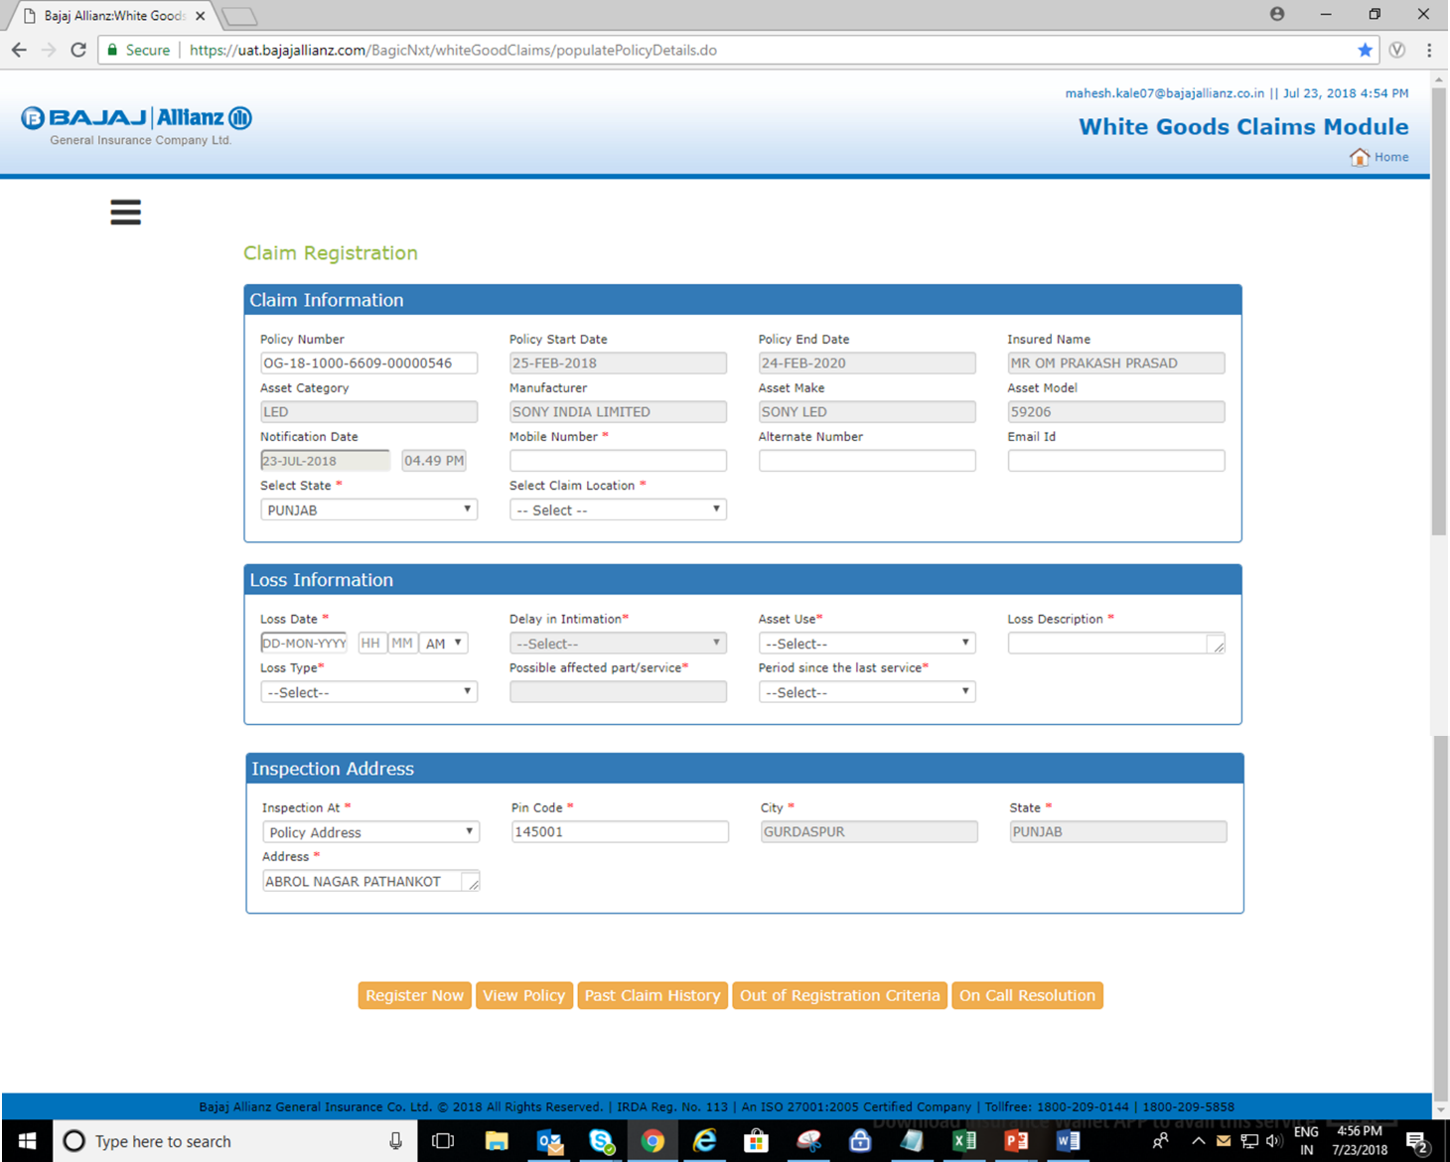

**New Enhancement on Claim Registration Screen.**

* **Claim Information Section –**

1. **On input of wrong policy no /Cancelled Policy No system will throws an alert message.**
2. **Policy Start & Policy last & Policy holder mobile no, Alternate no, Email Id will be reflected by default which were captured in policy & fields are kept editable to update these details**

**If customer want to change.**

* **Validations –**

**Mobile No. should be start with 6,7,8,9.**

**Email ID Should be in correct format.**

1. **State name will be auto reflected in “Select State “dropdown which would be available in inspection address field.**

* **Loss Information**

1. **On selection of Loss date system will be thrown an alert message if selected date is not covered within Policy Period.**
2. **If Loss date is 30 days prior to system date & time system will ask the “Reason of Delay” In claim registration.**
3. **Need to select Delay reason from below master.**

* **Delay in Intimation Reasons**
* **Customer Out of Station**
* **Policy Documents not received**
* **Could not connect BAGIC**
* **Not aware of Claim Procedure**
* **Emergency Situation**

1. **Asset Use –**

**Private**

**Commercial**

1. **Loss Description-Up to 250 char.**
2. **Loss Type- According to asset category Loss type dropdown will be reflected .on Selection of loss type possible affected part will be auto reflected on screen.**

* **Period Since the last service- For Air Conditioner & Washing Machine Last Service period selection is mandatory .Master is as below-**

**Period Since last Service done**

* **0 -1 Month**
* **3 Months**
* **3 - 6 Months**
* **6 - 12 Months**
* **Above 12 Months**

**New Added buttons & functionality**

* **Out of Registration Criteria - If Asset Use is selected as “commercial” then it is not covered in policy T&C, Hence it will consider as Out Of registration criteria. On click of same button system will be generated Reference no.**
* **On call Resolution-If customer agreed on given resolution of the asset problem on call by Customer Care Executive then Call Should be closed by using “On call resolution “button with OTP Confirmation.**
* **Inspection Address-**

**Customer address which was captured in policy will be auto reflected in asset inspection section & same time new address captured facility is also available as existing if customer want asset inspection on new address.**

**Claim Allocation**

**Claim allocation to service provider process will be same as existing Auto allocation or manually.**

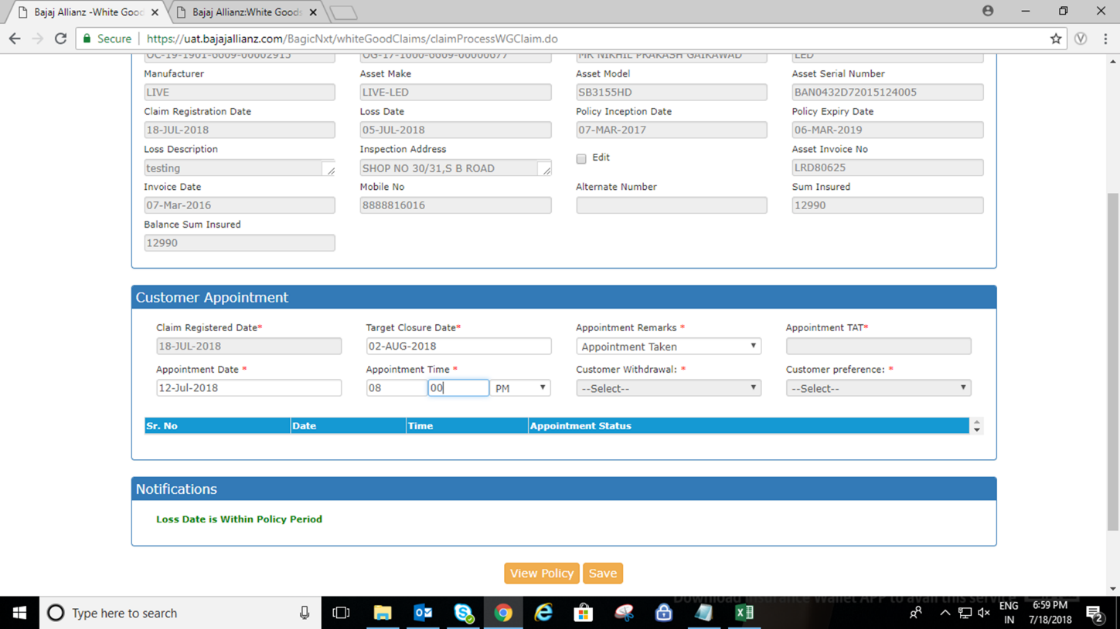

**Appointment Taken**

* **Appointment Taken –**

**For Appointment Need to select Appointment taken in “Appointment remarks “Screen & select date of appointment taken & time and click on Save Button.**

* **Customer Claim withdrawn –**

**If Customer want to Withdraw Claim then click on customer withdrawn dropdown and select proper reason. On selection of withdrawn “Cancellation Initiated” button will be enabled click on the same and enter withdrawn comments and save. Claim status will be changed as “Cancellation Initiated. Master as below**

* **Out of Station**
* **Resolved at Cust. End**
* **No response**
* **Not interested to claim for less amount**
* **Asset working fine**
* **Customer denied for Repair**
* **Customer repair own choice**
* **Customer Preference –**

**Dropdown to select customer preference in asset inspection at Appointment taken stage. Master as below-**

**Rescheduled - Cust. Pref.**

**Cust. Not reachable**

**Cust. Not available**

**Delay in Allocation**

**Upcountry Call**

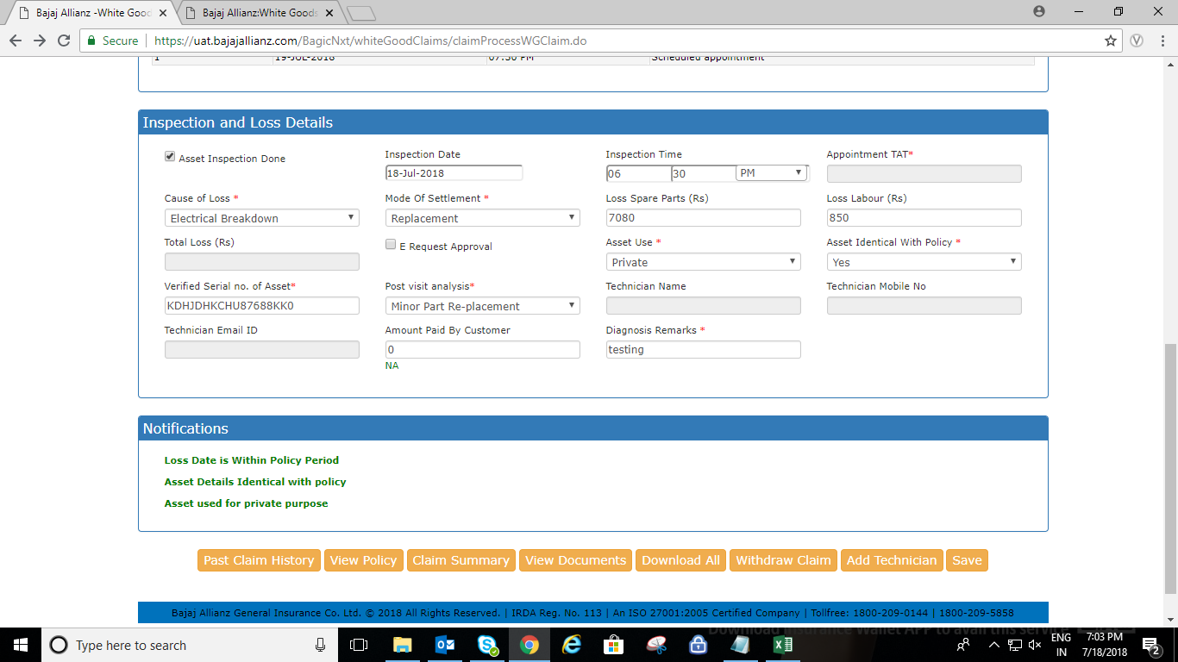

**1st Visit Done.**

* **Select Check box in Asset inspection done.**
* **Enter inspection date –**
* **System will accept system date & time or 1 day prior to system date & after claim registration date.**
* **System will allows to save Inspection date & time separately Without fill all Mandatory fields in “Inspection & Loss details” section & 1st visit date will be reflected in claim history. Then user need to be uploaded Preliminary documents to fill other mandatory details in “Inspection & Loss Details “Section.**
* **Cause of Loss-Need to select from below cause.**
* **Electrical breakdown**
* **Accidental damage**
* **Mechanical breakdown.**
* **Mode Of Settlement - Need to select from below.**
* **Repair**
* **Replacement**
* **Self-Repair**
* **Total Loss.**
* **Enter Loss Spare Part amount & loss labour Amount.**
* **Select asset use –Private /Commercial.**
* **Select Policy Identical with policy –YES /No.**
* **Enter Verified Serial No.**
* **Post visit analysis –from below dropdown as according to 1st visit**
* **Minor Repair**
* **Minor Part-Replacement**
* **Major Repair**
* **Major Part Replacement**
* **Repudiation Initiated-On selection Of Repudiation initiated reason need to select from below.**
* **Asset repaired before intimate**
* **Burnt Damage**
* **Commercial usages**
* **Consumables not covered**
* **Customer is outstation**
* **Filter not covered**
* **General service**
* **Insect damage**
* **Not contactable**
* **Physical damage**
* **Policy Mismatch**
* **Rusting**
* **Set working fine**
* **Cancellation Initiated -On selection Of Cancellation initiated reason need to select from below.**
* **Out of Station**
* **Resolved at Cust. End**
* **No response**
* **Not interested to claim for less amount**
* **Asset working fine**
* **Customer denied for Repair**
* **Not ready for Inspection**
* **Customer not reachable**
* **customer repair own choice**
* **Self-repair Initiated.**
* **Enter Amount paid by customer.**
* **Diagnosis Remarks after 1st visit.**

**Functionality**

* **If Post visit analysis selected Cancellation /Repudiation Initiated and need to close on “0” amount then those claims should close through Generic Module.**

**Ho User will close the claim and claim status will be changed as Cancelled –Payment not applicable & Repudiated –Payment not applicable.**

* **If Post visit analysis selected Cancellation /Repudiation Initiated and need to pay service /labour charges amount to ASP Then need to fill estimate for process the claim further .**
* **If ASP Selected mode of settlement as Replacement & if the claim is consider for total loss then ho user should change the claim settlement mode through manually by using “Claim**

**Modify “button as existing.**

* **After filled 1st visit details Asp need to upload Preliminary documents as**
* **Claim Form**
* **Job Card**
* **Asset Photographs**
* **Asset Serial no.**

**Estimate Uploaded**

* **After Filled 1st visit details & Preliminary documents uploaded estimate details screen will be reflected where ASP will fill the estimate details.**
* **Asp Name, Diagnosis Remark & Estimate date will be auto reflected and editable.**
* **Click on “add” button to enter estimate as existing & enter the details & click on “Estimate Upload “button.**

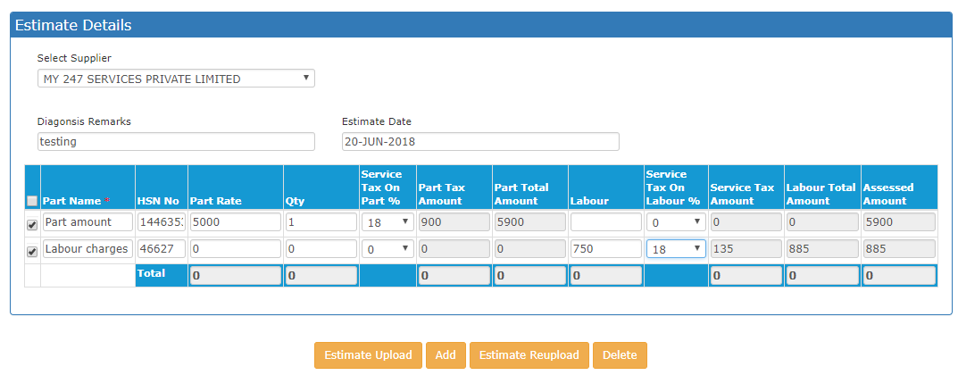

**Estimate Approved, More ifo.Required, Total Loss Initiated-**

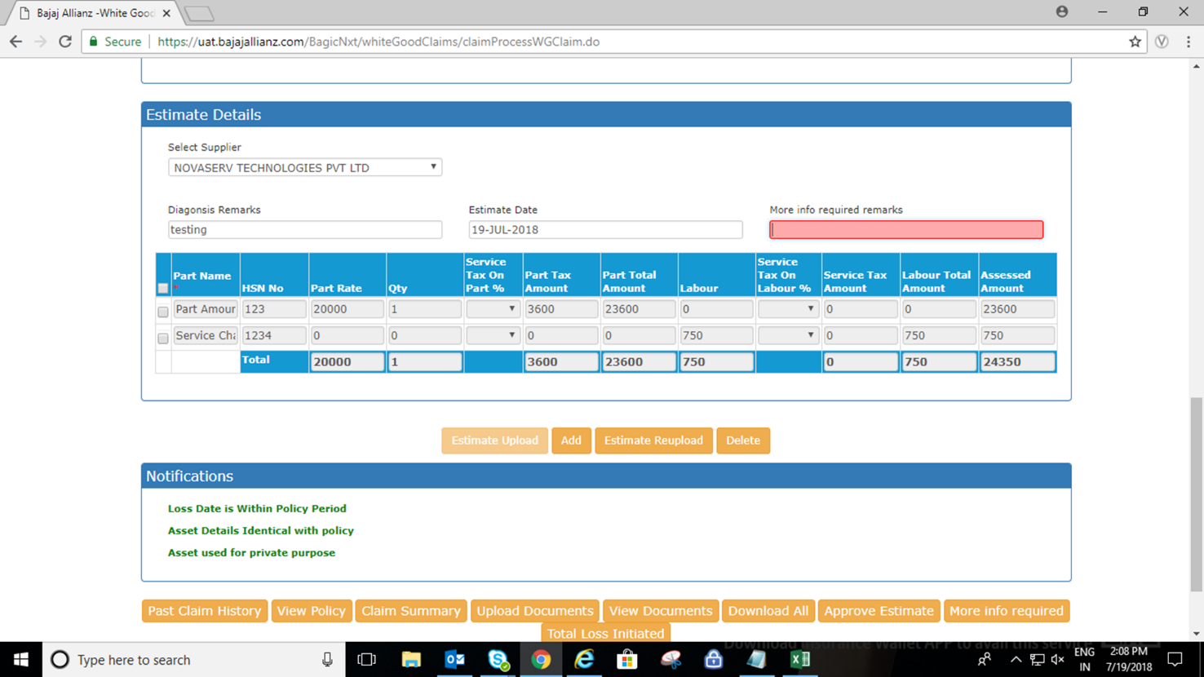

**Estimate Approved –**

* **If claim is admissible after reviewed of Details & documents uploaded by ASP then HO user should approve the estimate for start Repair Work or Payment to SVP as according to selected Mode of settlement. Approved amount will be reflected in claim history also.**

**More ifo.Required-**

* **If more info.requiredfor approve the estimate after reviewed of Details & documents uploaded by ASP then HO user should send requirement by using “More Info. Required” button. On click of “More Info. Required” comment box will be reflected, enter the requirements and click again on “More Info. Required”.**

**Total Loss Initiated-**

* **If more HO user found the estimate amount after reviewed of Details & documents uploaded by ASP is more than or prior to balance sum insured amount then HO user should initiate total loss by using “Total Loss Initiated” button.**

**Physically Closed-**

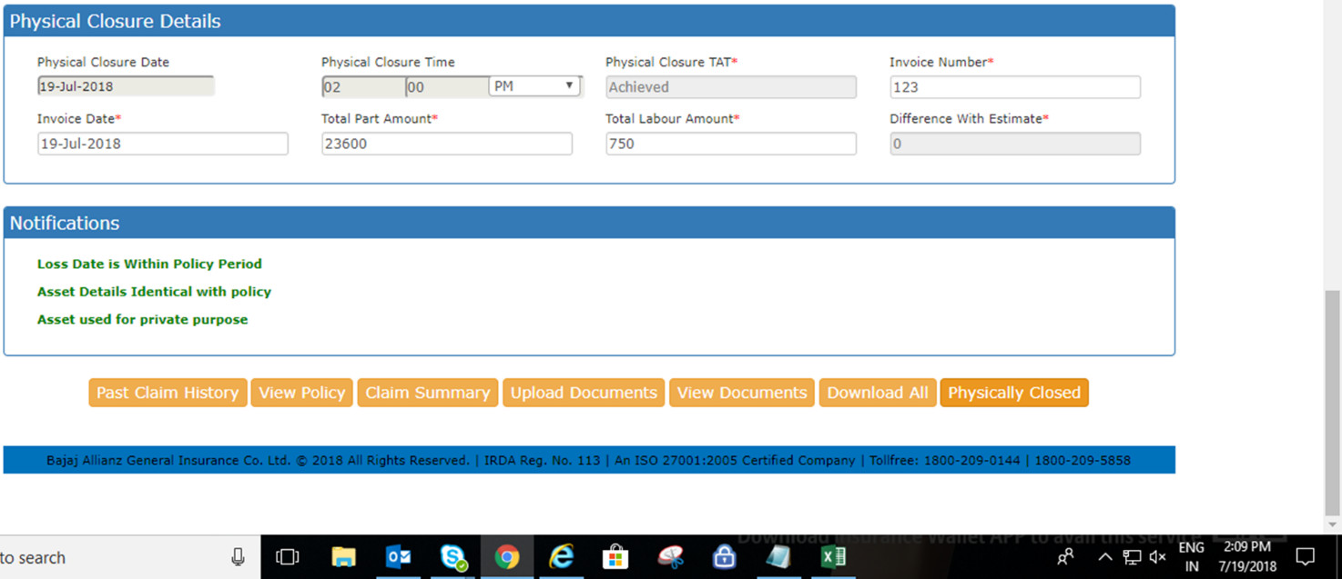

**Once ASP Completed Repair Work & handover the asset to Customer He should update the Physical closure details.**

**System will allows to enter Physical closure date within the claim registration date & System date & time only.**

**Asp Should Update the Physical closure date & time separately if don’t have invoice details.**

**All details need to fill in “Physical closure details “section are mandatory. After filled complete details as Physical closure date & time, Invoice Number Invoice date then only system allows to move on next claim status.**

**Final Documents Uploaded-**

**After filled physical closure details need to upload final documents & invoice. System will allow to RFA only after upload Final documents & invoice only.**

**RFA Done-**

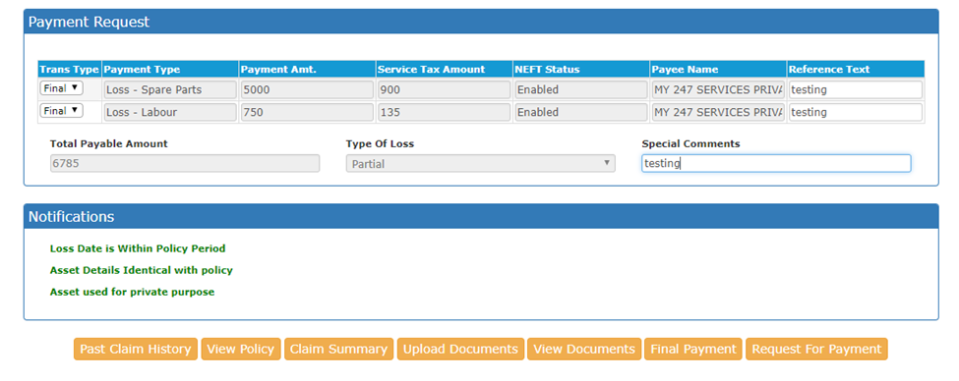

**Modify The Claim manually and Update RFA Details and click on “Request for payment” as Existing.**

**Claim Approval -**

**Approver will check the details & approved the claim.**

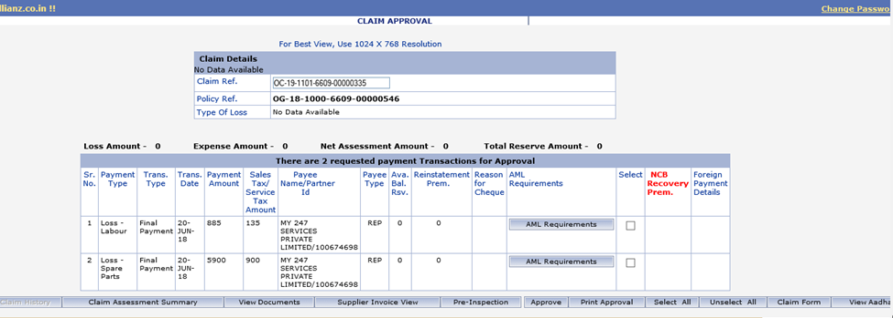

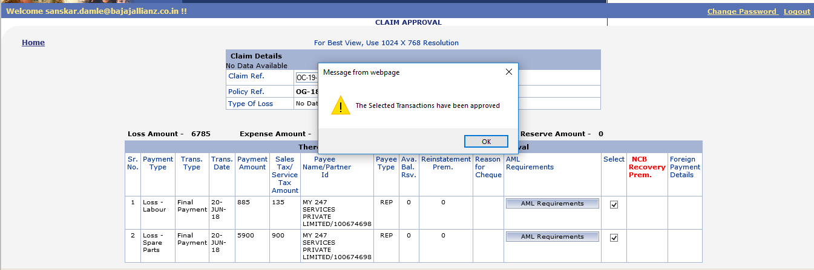

Thank you